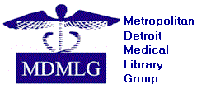

METROPOLITAN DETROIT MEDICAL LIBRARY GROUP (MDMLG)

2022-23
ARCHIVIST

REPORTS:
- MDMLG Bylaws has been revised and approved by the membership at the MDMLG General Business meeting in September 2021 to allow transferring ownership of archival materials.
- The Deed of Gift between MDMLG and the Reuther Library, Wayne State University, has been in effect since 2022.
- The remainder of physical archival materials will be deposited to Reuther Library.

GOALS:
- Collaborate with the MDMLG Webmaster to discuss the best approaches to archive born-digital materials.

Respectfully submitted,
Ella Hu

